PROJECT PROPOSAL: AUTOMATED CAFETERIA ORDERING SYSTEM

BY

MOHAMMED LAWAL, MARYAM

171103079

SUBMITTED TO

DEPARTMENT OF SOFTWARE ENGINEERING AND INFORMATION TECHNOLOGY

NILE UNIVERSITY OF NIGERIA

IN PARTIAL FULFILMENT OF THE REQUIREMENTS FOR

THE AWARD OF BACHELOR OF SCIENCE HONOURS

(B.Sc. Hons), DEGREE IN INFORMATION TECHNOLOGY

FACULTY OF NATURAL AND APPLIED SCIENCES,

NILE UNIVERSITY OF NIGERIA, ABUJA.

NOVEMBER 2021

# Table of Contents

Table of Contents ii

Chapter 1: Introduction 1

1.1 Background of Study 1

1.2 Statement of Problem 2

1.3 Aims and Objectives 2

1.4 Significance of Study 3

1.5 Justification of Study 3

1.6 Scope and Limitations 4

Chapter 2: Literature Review 6

2.1 Introduction 6

2.2 Full Service Restaurants 6

2.3 Self-Service Ordering In a Cafeteria 6

2.4 Automated Online Ordering System 7

2.5 Research Questions/Literature Gap 7

Chapter 3: Methodology 8

3.1 Project Timeline using Gantt chart 10

Chapter 4: Conclusion 11

References 12

# Introduction

## Background of Study

The integrality that technology has become in our lives, individually and wholly as a globe cannot be denied in this age. From how people of all parts of the world being able to very conveniently seek out just about any data with ease from just about any location, there's a harmony it brings, this seamless interaction with information at all times. In this current age, it would be a great difficulty for an establishment to survive on its own without setting information technology (IT) as its core. Such company would very easily be overthrown by any new competitor that is more accepting of having IT at its business core. Today's technological advancements are increasingly allowing much of the work that is currently done by humans to be automated. (O'Halloran, 2015).

Coming to the hospitality industry, where canteens, restaurants, cafeteria, and the like can be found, many restaurants look to give focus on speedy preparation and delivery of the orders placed, as opposed to creating an exquisite dining experience for the customer, which is not a good enough approach, especially not in today current time where there are plethora of fast food and takeaway restaurants and cafeteria all around.

Without an automated ordering system, you'd have to hire someone whose sole responsibility would be to answer the phone. Taking orders is only a small part of food delivery; hence this is a pricey solution. (2021)

A cafeteria automation system, an online ordering technique that can be used in any meal delivery sector to help curb these problems is my proposal. The key benefit of this technique is that it makes ordering more trouble-free for both the consumer and the cafeteria. End users of the system can easily go online, go through the menu and select food from an e-menu provided and order food online by simply selecting the food they wish to eat right there on the website.

## Statement of Problem

Customers will have difficulty deciding what they want to eat in that restaurant if the menu is implemented in an ad hoc manner in a traditional menu system (paper-based system). There’s a concern when the lack of room required displaying all of the food photographs on a paper-based menu, combined with the time spent on a queue while waiting to be attended to in a crowded space at the high probability of miscommunication in customer orders are all looked at. The proposed system will aid in the resolution of these issues.

## Aims and Objectives

### Aim

The aim of this project is to develop an automated cafeteria ordering system that could be used to improve quality of customer experience when ordering from a restaurant in an automated and quicker fashion. Thereby, lessening the need for slow, manual paper work in the service provided.

### Objectives

1. To design a web application for customers at a cafeteria to use for quick meal ordering.
2. To develop a web application for ordering food in a cafeteria.
3. To evaluate the developed web-based ordering system using some test cases.

## Significance of Study

Automation is the development and deployment of technologies that allow goods and services to be produced and delivered with minimal human interaction. The simplest method is to automate the simple tasks of sending data. This is how a restaurant's automatic ordering system works.

Automation is said to have a lot of positive effects, such as saving time, money, and energy. But, at a restaurant where human relations and hard effort are so crucial, how do you automate processes? Of course, some of these processes are unavoidable, but others can be aided by a computerized ordering system.

Advantages of such a system include:

* The time wasted queuing to make an order is eliminated, allowing for faster interaction with the customers.
* Through making use of simple and comprehensive interface, the food ordering pages can have a look and feel identical to the restaurant itself.
* Through the usage of this program, the specifics of a customer's orders can be quickly obtained without fear/concern of order details being incorrect.
* Without trouble, the user can order food from anywhere and at any time right from the comfort of tap of their devices.

## Justification of Study

Looking at the busy work schedules of students, staff and others alike, many find it difficult to go to the cafeteria, wait in line, and be served to eat. In today's fast-paced society, there is a need to have things done much quicker. The following are the anticipated project benefits:

* The ordering procedure will be sped up.
* Due to the rapidity of execution, there will be no long lines at the counter.
* Because it is a machine, the system will be less likely to make mistakes.
* The most significant advantage of online ordering is the labour savings, as staff are able to save time considering how they are not engrossed in a phone conversation or at a counter.
* Another advantage for the restaurant was order accuracy as it strengthens customer to business relationship. (Kimes, 2011)

## Scope and Limitations

### Scope

The scope of this project is to develop a web application that presents features that would allow for the removal of difficulties involved in placing order at the cafeteria on both the customers end and in running the business as a whole.

### Limitations

The limitation of this system includes:

1. It needs a stable and running internet connection to be able to access the web application.
2. Any financial transactions between customer and business as customer would make payment upon arrival to the cafeteria.
3. Probability of technical problem or fault with the system.
4. Risk of discrepancies in customer and order information from using 3rd party applications.
5. The system's other drawback is that it will only be useful to people in a narrow geographic area, namely only around the university cafeteria, implying that it can only assist a limited number of people.

# Literature Review

## Introduction

In modern times, a lot of cafeterias have a traditional food order process begins with customers viewing a paper-based menu and then the waiter bidding his time for them to select from the menu. All records are kept on paper in this system. The biggest disadvantage of this technique is that papers are easily misplaced or damaged to the customer’s dissatisfaction (Chavan, Jadhav, Korade, & Teli, 2015). Automation through some form of application that is integrated into the cafeteria business can enable employees to effortlessly manage orders in a faster, sequential manner and decrease human error. A great deal of study has gone into developing an automated cafeteria ordering system. This section depicts as prior research and products in the subject of automated food ordering. In the following lines are reviews of previous systems.

## Full Service Restaurants

Typically, the method here requires the guests to be seated or standing on a queue in the restaurant and the assistance of a waiter or attendant noting down the ordering. This traditional paper-based system is one of the most extensively used meal ordering systems. All records are kept on paper in this system which requires a significant amount of human effort, even with minor changes. This could overall be time consuming from the customer's perspective. (Chavan, Jadhav, Korade, & Teli, 2015).



## Self-Service Ordering In a Cafeteria

In the restaurant (cafeteria-focused) industry, self-ordering restaurants allow customers to place an order via the touch screen devices or PDAs, and the order will be delivered to the bar or kitchen. Customers will be given internet access in the future, and the system will also offer games once they have placed orders. The use of a touch screen ordering system eliminates the need for a waiter. The system also includes a database tracking client habits and preferences, as well as the ability to generate management reports, conduct analyses, and submit menus instantaneously. (Brickers, 2006).

## Automated Online Ordering System

In (Bhargave, Jadhav, & Joshi, 2013), a web services-based solution for hotel management system integration is shown. The Digital Hotel Management holds the Ordering System, Kitchen Order Ticket (KOT), Billing System, and Customer Relationship Management System (CRM) together. This approach made it possible to add or grow hotel software systems in any size hotel chain setting.

The Online Ordering System is a method of allowing customers to order their favorite foods via the internet using a web browser installed on their computer or smart phone. Implementing this technology can assist the fast food businesses in overcoming the challenges they have when using standard meal ordering methods.

## Research Questions/Literature Gap

So, what if there was an automatic way to order from the cafeteria and have the food order ready waiting for them when they arrived? Will the waiter's or attendant's workload be decreased as a result of the installation of this system? Yes. Would the restaurant's work efficiency be improved? Yes. Would providing this service boost consumer satisfaction? Yes.

# Methodology

SDLC Methodologies are the methods and techniques that software development teams use to navigate the Software Development Life Cycle successfully (SDLC). There are six different SDLC models, each with numerous phases. They include Agile, Lean, Waterfall, Iterative, Spiral, and DevOps. (Half, 2021)

Each of these approaches is unique in some respects, but they all serve the same goal: to assist teams in producing high-quality software as rapidly and cost-effectively as feasible.

My chosen methodology going into this project is the Agile Methodology. Because of its flexibility and evolving character, Agile has become one of the most popular techniques to project management today with its combination of both iterative and incremental approaches all in one. It comprises of several methodologies, all of which are founded on the ideals of flexibility, transparency, quality, and continual improvement. Due to the limited time available to work on this project, this is a very important benefit of working with this methodology.

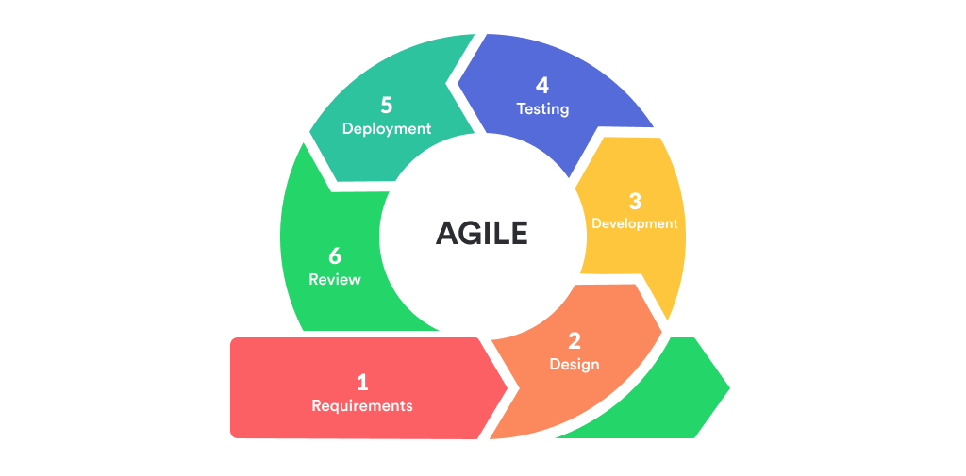

The proposed automated cafeteria ordering system will be a web-based program, and there are measures to be followed in order to achieve a solution to the above, which are as follows:

* **Phase 1: Requirements**

The system's needs have been gathered and documented at this phase. The plan, timing, and budget for completing the iterations are prepared in this step. It’s important to know what the product end-users would be looking for. At this stage the requirement document is created, containing both functional requirements (such as user interface and homepage) and non-functional requirements (such as user-friendly environment) of the system.

* **Phase 2: System Design**

The documents obtained from the previous phase will be used in this phase which entails the methodologies utilized to develop the platform, including mock-up designs, user interface and backend functionalities, and the programming languages used to accomplish this. The design document would be created in this stage.

* **Phase 3: Implementation**

The design document of the previous phase will now be used in this phase that entails the development of a web-based application. It is here that we will write the code for the system, which will be written on the client side using Cascading Style Sheets (CSS), Hypertext Mark-up Language (HTML), JavaScript, and some of its frameworks, and on the server side using Hypertext Pre-processor (PHP), Structured Query Language (SQL).

* **Phase 4: Testing**

This is the stage in which our implemented application is tested to ensure that it is fully functional and meets all standards, allowing people to utilize the platform without inconvenience.

* **Phase 5: Deployment**

The software reaches the deployment phase when it has been thoroughly tested and all essential iterations have been completed. The project is then made available to the general public.

## Project Timeline using Gantt chart

Below, shows estimate duration for the different phases in this project development. Please note that the dates are subtle to change.

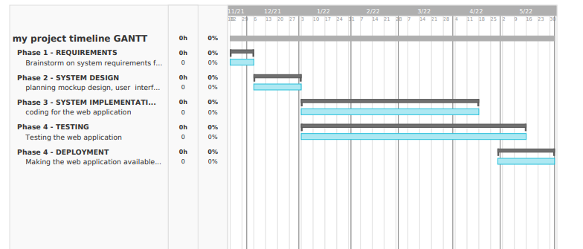

# Conclusion

When the project is completed, the following outcomes are expected:

* A well-functioning, user-friendly online application with a nice, comprehensive user interface and experience.
* A site where users may log in and search through the e-menu provided to make their orders.
* A fully functional web-based application.
* Better and faster efficiency in how the cafeteria handles the orders coming in.

The proposed approach will improve the manner in how the business venture handles orders from customers in a better fashion than the traditional method. Customer satisfaction will be improved on one hand and the business productivity, income and efficiency will also be boosted.

# References

*Automated Ordering System – How to Save Time and Effort in Restaurant*. (2021, April). Retrieved November 5, 2021, from Upmenu: https://www.upmenu.com/blog/automated-restaurant-ordering-system-automate-your-restaurant/

Bhargave, A., Jadhav, N., & Joshi, A. (2013). Digital Ordering System for Restaurant Using Android. *International Journal of Scientific and Research Publications*.

Brickers, J. (2006, July 24). Is Fast Casual Self-Service at the Tripping Ponit?

Chavan, V., Jadhav, P., Korade, S., & Teli, P. (2015). Implementing Customizable Online Food Ordering System Using Web Based Application. *International Journal of Innovative Science, Engineering Technology(IJISET)*.

Chavan, V., Jadhav, P., Korade, S., & Teli, P. (2015). Implementing Customizable Online Food Ordering System Using Web Based Application. *International Journal of Innovative Science, Engineering Technology(IJISET)*.

Half, R. (2021, October 28). *6 Basic SDLC Methodologies: Which One is Best?* Retrieved November 9, 2021, from RobertHalf: https://www.roberthalf.com/blog/salaries-and-skills/6-basic-sdlc-methodologies-which-one-is-best

Kimes, S. E. (2011). *The Current State of Online Food Ordering.* New York: Cornell University.

O'Halloran, D. (2015, August 13). *How technology will change the way we work*. Retrieved November 8, 2021, from WeForum: https://www.weforum.org/agenda/2015/08/how-technology-will-change-the-way-we-work/